**ASSIGNMENT 1**

**Problem Description:**

In this assignment, we were tasked to write a Java program to implement the ASCII stickman climbing the stairs below using two parameters for the height of the stickman and for the height of the stairs.

The program should have at least two methods and it needs to be coded using for loop statements.

**Problem Solution:**

In my program, there are 3 methods, 10 for loop statements and 15 variables. First method is the main method which includes the variables *stickmanHeight, stairHeight* and the second method *StickManOnStair.*

The variable *stickmanHeight* stands for the height of the stairman; the number of lines including the head, the torso and the feet of the stair man pattern. It can be changed to any variable, however, it must provide the equation, *stickmanHeight*>=s*tairHeight*+2.

The variable *stairHeight* stands for the height of stair; the number of how many lines the stair have.

The method *StickManOnStair* has three parts inside. First; The part which includes the head and the arms of the stickman, second: The part which includes the stickman’s torso **which there is not a part of stair in the same line**, third: The part that **includes a part of stick man’s torso and a part of stair at the same line**, fourth: the feet and the step of the stair, and fifth: The part of stair **which there is not a part of stick man at the same line**. All these parts depend on variables, in order to change their quantity at every frame(any step of stickman).

The method *StickManOnStair* is depend on two integer variables, x and y. The x variable is assigned to the variable *stickmanHeight*, and the y variable is assigned to the variable *stairHeight* when it is called in main method.

Inside the method *StickManOnStair*, the first for loop is used to make the stickman design climb up to the stairs. Because the stickman moves along the stair, for any number given for the variable *y,* stickman should move up *y+1* times. The variable *stepcount* is assigned at 0 and it must be smaller than y+1, in order to make the stickman climb up y+1 times.

Inside the first for loop, there is an another method called, named *spaces*. Spaces method includes a for loop for the number of spaces which will be printed before any other character is printed. There is a need for number of spaces to change dependently to the variable stepcount, because every time the stickman takes a step, the number of spaces before it changes in a certain number*, 3*stepcount*. The method *spaces* is defined with variable x and in the program every time it is called, the *stepcount* is assigned to x.

In order to make the stairman aligned, before every time a part of the stickman is printed, the *spaces* method is called.

There is a method called headandArms.It prints out only the head and the arms of the stickman. Because the height of stair is smaller than the height of stickman at least by two, there will never be a part of stair at the same line with the arms of the stickman.

After that, there is a for loop for the length of the part of the stickman’s torso which there is not a part of stair at the same line. The number for this part must depend on the values *x, y* and *stepcount*, because every time the stickman takes a step, or the height of it or the height of stair is changed, the length changes also. The equation which provides this situation is the value *torso<x-y+stepcount-3.*

In that for loop statement, the character for the torso”|” is printed.

The third for loop statement is used to define the number of the lines the stair has. It also includes a part of stairman’s torso in it. The part of torso and the stair is considered a pattern together. The variable *line,* the number of line of the stair, is dependent to *y*  and *stepcount*  variables, because in a perspective, every time the stickman takes a step, the stair above it vanishes one line and appears below it. That’s why the variable *line*<*y-stepcount.* Inside the for loop, the *spaces*  method is called and the torso “|” is printed. After the “|” there needs to be spaces in order to pattern the stair. 4th for loop statement is tasked to do this. The number of spaces depend on the *line, y* and *stepcount* values.

After that, the stable parts of the stair(floor and the”|”) are printed and the 5th for loop is to print the number of stars each step. The number of stars only depend on the variable *line*.

Then, the feet of the stickman is printed, and the number of stars at the same line with the feet must be depend to a different function than the rest of the stair because as the stairman goes up, the number of stars cannot be resolved to the equation which is only dependent to the variable *line.* The 6th for loop statement is designed to print the number of stars. It depends on the variables *y and stepcount*.

Below the feet of stickman, there must be the rest of the stair. Even though there is not in the first frame, it occurs as the stickman goes up. 7th for loop statement is to print the rest of the stair. 8th for loop includes the number of spaces going to be printed. The number of spaces is depend on the variables *line2,the variable for the number of lines the rest of the stair has,* and the *stepcount.*

After the stable parts of the stair are printed, a for loop is created to determine the number of stars each step. Naturally, it depends on the variables *line2, stepcount,* and *y.*

At the end of any frame, there supposed to be lines before a new frame starts to be printed out. The number of these lines decrease as the man climbs up. It also depends on the stair height. Another for loop is used here depending on the variables y and stepcount.

**Submission:**

**public** **class** ES2018400183 {

**public** **static** **void** main(String[] args) {

**int** stickmanHeight = Integer.*parseInt*(args[0]);

**int** stairHeight = Integer.*parseInt*(args[1]);

*StickManOnStair*(stickmanHeight, stairHeight); /*this method is used to create the required pattern: stickman climbing up*/

}

**public** **static** **void** StickManOnStair(**int** x, **int** y) {

**for**(**int** stepcount=0; stepcount<y+1; stepcount++) /*count of the frame */ {

*spaces*(stepcount); /*this method is used for the number of spaces before the stickman*/

System.***out***.println(" O");

*spaces*(stepcount);

System.***out***.println("/|\\");

**for**(**int** torso=1; torso<=x-y-3+stepcount; torso++) { /*count of the torso without stair*/

*spaces*(stepcount);

System.***out***.println(" |");

}

**for**( **int** line=0; line<y-stepcount; line++) { /*count of the stair line*/

*spaces*(stepcount);

System.***out***.print(" |");

**for** (**int** spaces=1; spaces<=-3*line+3*y+1-(3*stepcount); spaces++) { /*count of the spaces between the man and the stair*/

System.***out***.print(" ");

}

System.***out***.print("___");

System.***out***.print("|");

**for**(**int** stars=0; stars<3*line; stars++) { /*count of stars in the stair*/

System.***out***.print("*");

}

System.***out***.println("|");

}

*spaces*(stepcount);

System.***out***.print("/ \\");

System.***out***.print("___");

System.***out***.print("|");

**for**(**int** starsBottom=1; starsBottom<=3*y-3*stepcount; starsBottom++) { /*count of the stars in the part of stair after the stickman's feet*/

System.***out***.print("*");

}

System.***out***.println("|");

//for the part of stair below the stickman's feet

**for**(**int** line2=0; line2<stepcount; line2++) {

**for**(**int** spaces=0; spaces<-3*line2+3*stepcount; spaces++){ /*count of the spaces at the beginning of the stair*/

System.***out***.print(" ");

}

System.***out***.print("___|");

**for**(**int** stars=0; stars<-3*stepcount+(3*y+3)+(3*line2); stars++) {

/* count of the stars at the stair*/

System.***out***.print("*");

}

System.***out***.println("|");

}

**for**(**int** a=0; a<y+1-stepcount; a++) { //count of the lines between each frame

System.***out***.println();

}

}

}

**public** **static** **void** spaces(**int** x) { /*this method is used to print the spaces before printing stickman*/

**for**(**int** spaces=0; spaces<3*x; spaces++) { /*count of spaces before the stickman*/

System.***out***.print(" "); }}

**public** **static** **void** headandArms(**int** x) { /* this method is used to print the head and arms of the stickman*/

System.***out***.println(" O");

*spaces*(x);

System.***out***.println("/|\\");

}

}

**Output of the Program:**

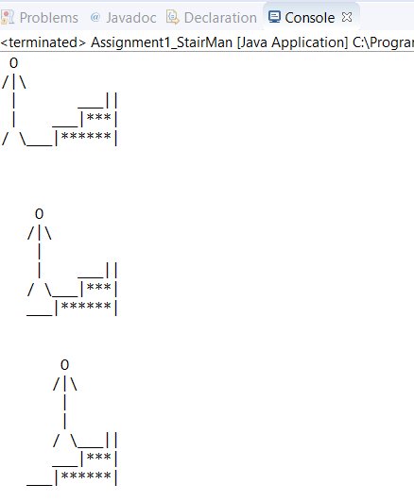

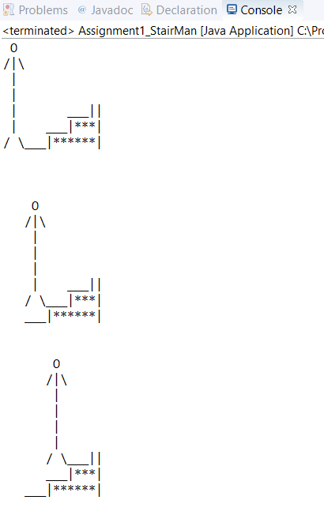**Conclusion:**

The program works perfectly. Therefore, it is stated that the problem is solved, successfully.

Ecenur Sezer

Student ID: 2018400183